How to find the mean of every NumPy array in the given list? Input: list = [ np.array([3, 2, 8, 9]), np.array([4, 12, 34, 25, 78]), np.array([23, 12, 67]) ]

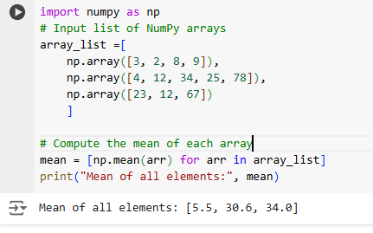

2. Compute the median of the flattened NumPy array Input: x_odd = np.array([1, 2, 3, 4, 5, 6, 7])

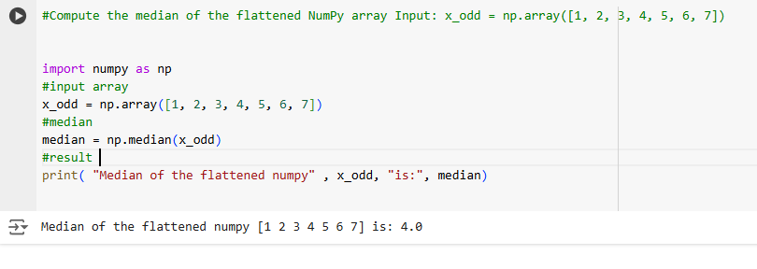

3.Compute the standard deviation of the NumPy array Input: arr = [20, 2, 7, 1, 34]

